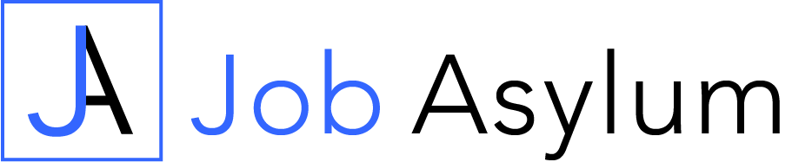
Job Interview Worksheet

Use this worksheet as a guide to prepare yourself for an upcoming job interview and map out the content of the answers you will give.

Company:
Job Title:

Why are you interested in this job role?

Why do you think you would be a good fit for this job role and company?

What are your strongest attributes and skills for this job role?

Where are you weakest in relation to the job criteria?

What could you learn or refresh your knowledge of prior to the interview?

How does this job role fit in with your overall career plans?

Job Responsibilities:

List the job responsibilities outlined in the job description | List examples of past experiences with these responsibilities or why you feel you would be good working with them
Example: Delivering exceptional customer service | Example:  - Previously worked as a manager in retail  - Enjoy working with the public
Example: Working as a key member within a small team | Example:  - Worked on several team projects in College  - Did internship working in a small team

Job Requirements:

List the required skills and knowledge outlined in the job description | List evidence of these skills and knowledge and where you have used them
Example: Ability to work to tight deadlines | Example:  - Generating sales reports in current job role  - Interned as a junior reporter at local newspaper
Example: Experience in managing Social Media campaigns | Example:  - Past Social Media campaigns managed in employment  - Qualifications in digital marketing

Job Interview Preparation Checklist:

Company Research

Have you researched the products/services the company offers?
Have you looked at the company’s website and social media accounts?
Have you searched Google for news articles involving the company?
Do you know anyone who already works there, that you could talk to?
Do you understand the industry the company operates in?
Do you know the size of the business and where they are positioned within their industry?
Do you know what the company’s culture is and what its core values are?

Job Profile

Do you have a good (or better) understanding of what the job consists of?
Do you have the desired level of skills and experience?
If not, how will you promote your current level as strong enough?
Are there any areas where you need to refresh or improve your knowledge prior to the job interview?
Have you identified which elements of this job you would be strongest and weakest at?
Do you have answers prepared for questions relating to the skills and knowledge required, as outlined in the job description?

Personal Profile

Does the company look like somewhere you would enjoy working?
What personal attributes of your own do you feel you can bring to the job?

Preparation

Have you planned your journey to the interview?
Is the journey one you would be comfortable making on a regular basis?
Have you got suitable clothing prepared for the interview?
Do you know the name of the person you are meeting?
Have you prepared some questions that you would like to ask the employer?
Do you have any supporting documents or a portfolio of work you can bring with you?

